Service of Gratitude
7:00 p.m. ~ November 22, 2023

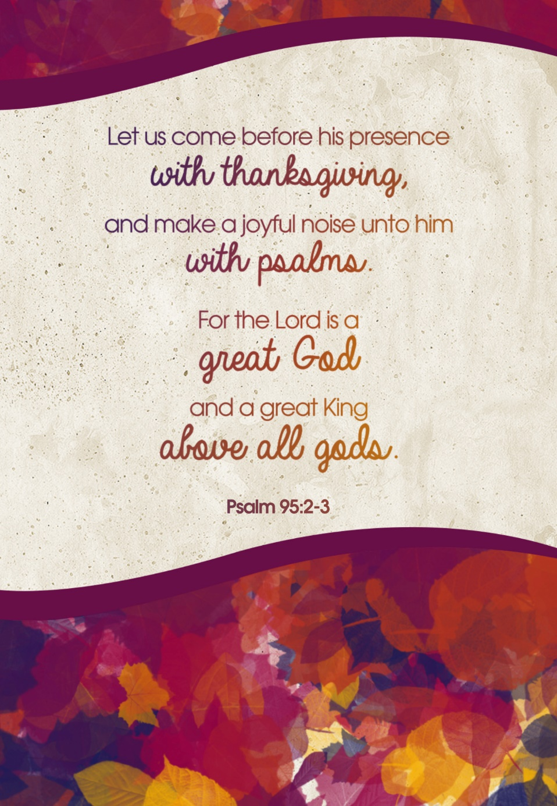

Immanuel Christian Reformed Church
Sheldon, Iowa
Service of Gratitude
7:00 p.m. ~ November 22, 2023

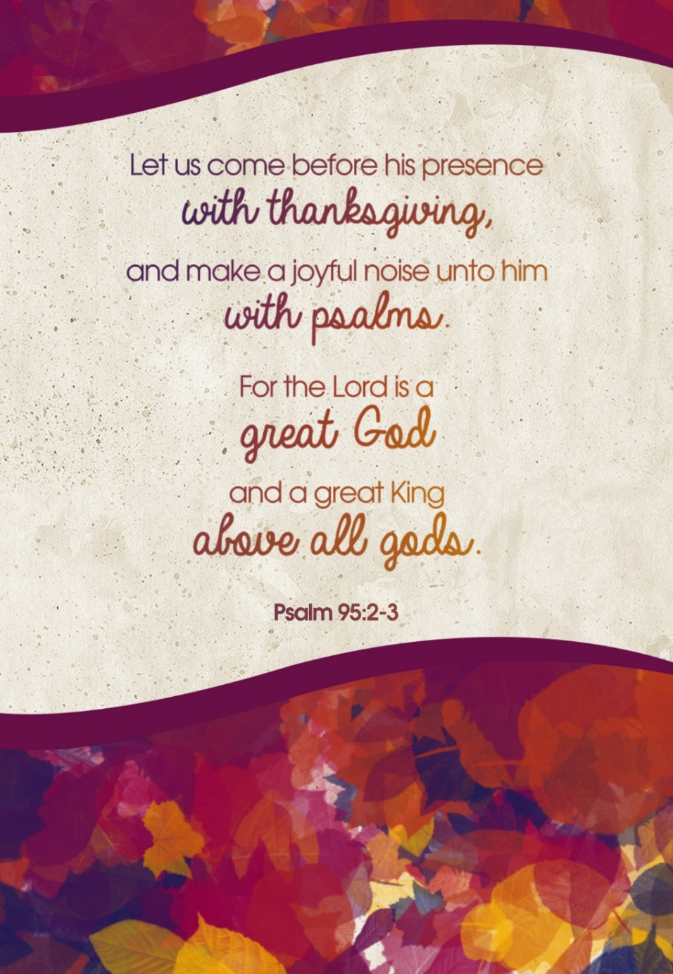

Immanuel Christian Reformed Church
Sheldon, Iowa
Prelude

Welcome

*God’s Greeting

*Hymn of Worship: “Let All Things Now Living” #453

*Call to Worship: Psalm 95

*Song of Praise: “Hallelujah for the Cross”

Choir: “Our Grateful Song”

Thanksharing
- Home and Family
- Health and Healing
- Creation and Beauty
- Jobs and Provision
- New Life and New Life in Christ

Prayer of Gratitude

*Hymn of Thanks: “For the Beauty of the Earth” #432 4 vs.

Scripture: Luke 17:11-17
Message: Nine Guys Who Missed Thanksgiving

Offering: Thanksgiving Envelopes
Offertory: “Gratitude”

1 Man Prayer

*Benediction

*Closing Song of Gratitude: “Thank You for the Cross”

Postlude

*Please stand, if able
Prelude

Welcome

*God’s Greeting

*Hymn of Worship: “Let All Things Now Living” #453

*Call to Worship: Psalm 95

*Song of Praise: “Hallelujah for the Cross”

Choir: “Our Grateful Song”

Thanksharing
- Home and Family
- Health and Healing
- Creation and Beauty
- Jobs and Provision
- New Life and New Life in Christ

Prayer of Gratitude

*Hymn of Thanks: “For the Beauty of the Earth” #432 4 vs.

Scripture: Luke 17:11-17
Message: Nine Guys Who Missed Thanksgiving

Offering: Thanksgiving Envelopes
Offertory: “Gratitude”

1 Man Prayer

*Benediction

*Closing Song of Gratitude: “Thank You for the Cross”

Postlude

*Please stand, if able

